

**UNIVERSITY OF PETROLEUM & ENERGY STUDIES**

**Dehradun**

**Application Containerization**

**Experiment 4**

**Name: Muskaan Madan**

**Course: B-Tech CSE DevOps (2018-22)**

**Roll number: R171218063**

**Sap ID: 500068520**

**Docker Images with ‘Dockerfile’**

**Creating custom Nginx docker image**

* Create an ‘index.html’ file:

touch index.html

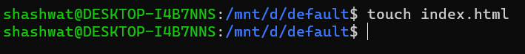

* Put some content into the file and save it:

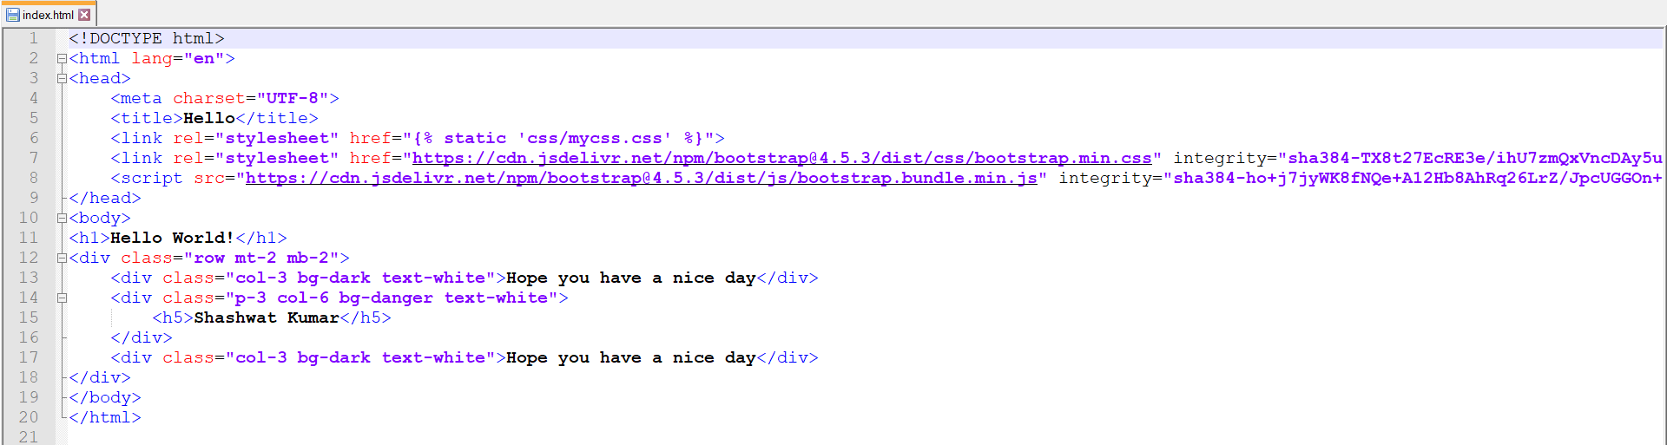

* Create a ‘Dockerfile’ file:

touch index.html

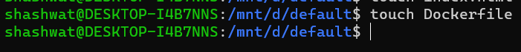

* Put the following content into the file and save it:

FROM ubuntu

RUN apt-get update

ENV DEBIAN_FRONTEND noninteractive

RUN apt-get install nginx -y

RUN echo "daemon off;" >> /etc/nginx/nginx.conf

COPY index.html /var/www/html/

EXPOSE 80

CMD ["nginx"]

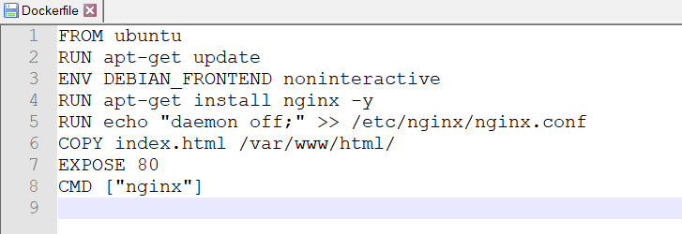

* Pull the Nginx image from Dockerhub:

docker pull nginx:latest

* Create the custom Nginx image using the Dockerfile (Be sure to be in the same directory as the one containing the Dockerfile):

docker build -t mynginx:v1

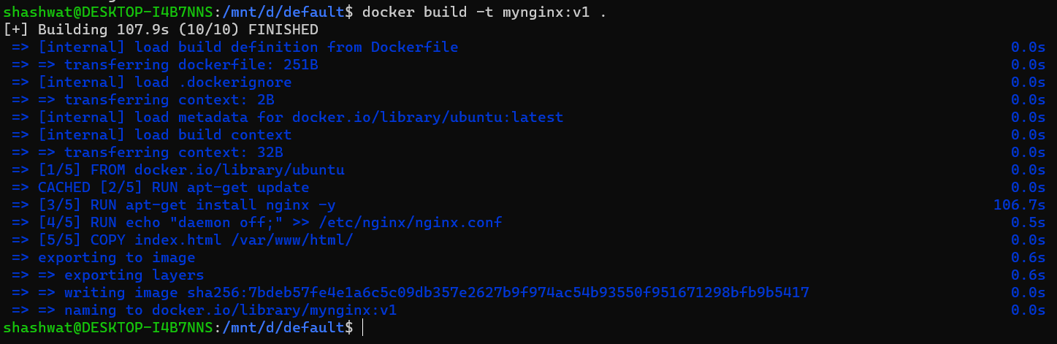

* List all images to see if you image was created:

docker images



* Run the newly created docker image (mynginx:v1):

docker run -d -p 5000:80 mynginx:v1

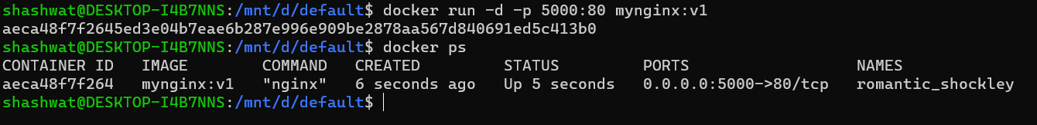

* Visit “localhost:5000” to see if the image is running successfully:

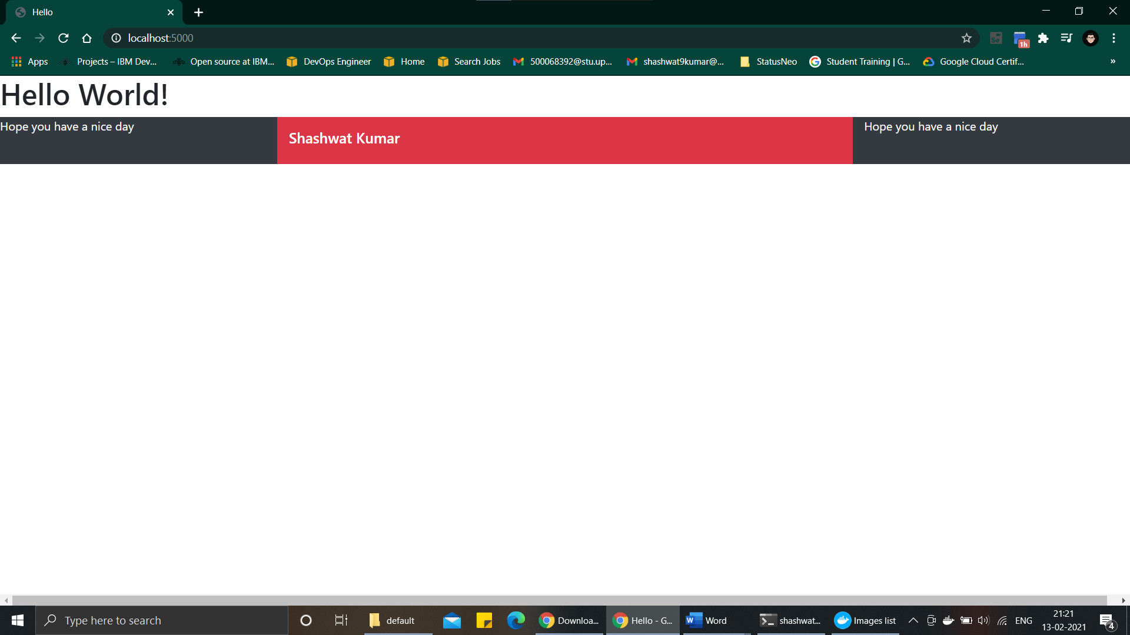

**Pushing custom Nginx docker image to ‘DockerHub’**

* Create a Docker-Hub account and create a repository
* Tag the newly created nginx docker image as “<original_name>:<tag> <dockerhub_username>/<repository_name>:<tag>”:

docker tag mynginx:v1 shashwat9kumar/mynginx:v1



* Login to Docker-hub and give your credentials:

docker login

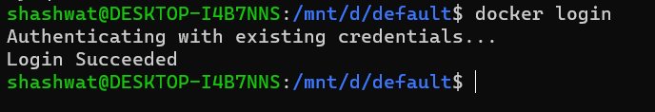

* Check if the tagged image is created:

docker images

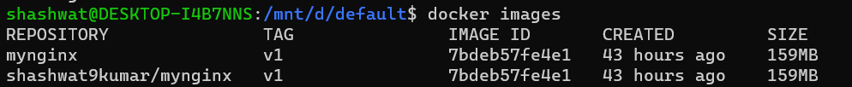

* Push the tagged custom docker image:

docker push shashwat9kumar/mynginx:v1

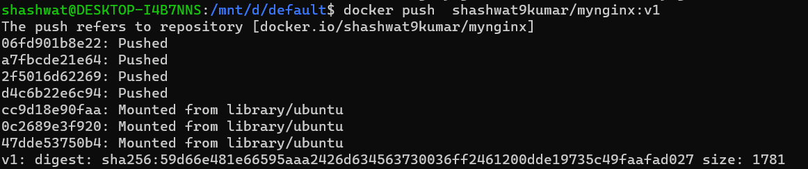

* Visit you Docker-Hub repository to see if your image was pushed and is available:

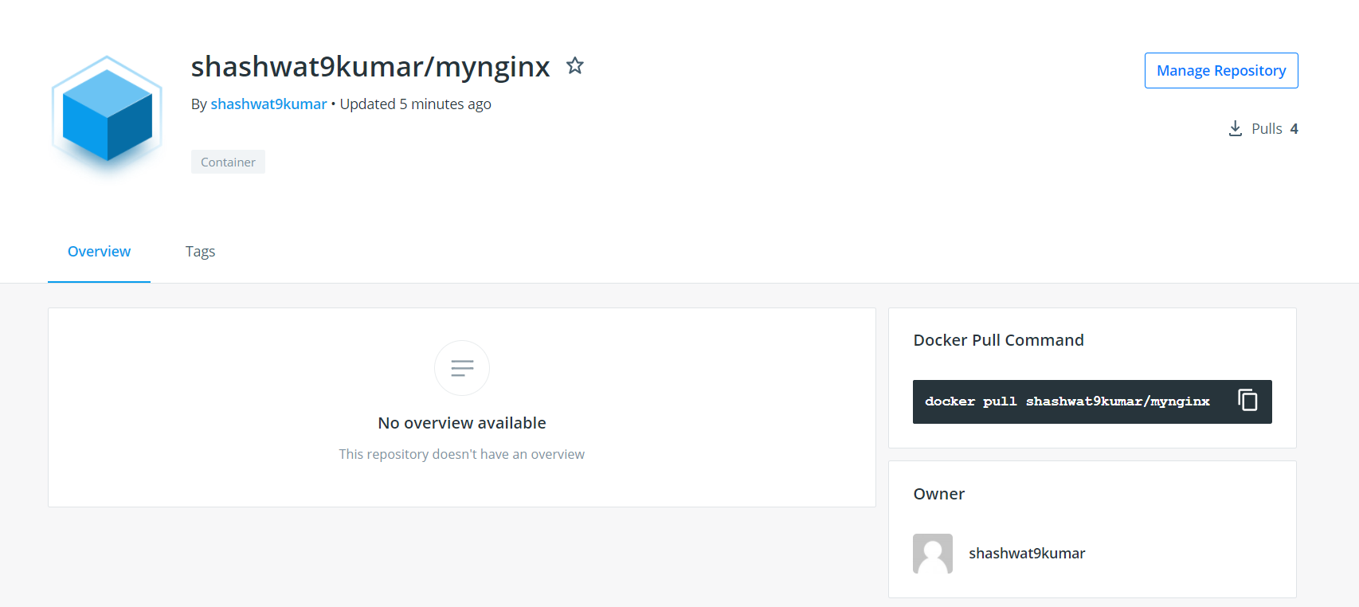

**Pulling and Running custom Nginx docker image from ‘Docker-Hub’**

* Use a different machine (not having the image locally or use docker playground)
* Pull the custom image from Docker-hub:

docker pull shashwat9kumar/mynginx:v1

* Run the pulled custom image:

docker run -d -p 80:80 shashwat9kumar/mynginx:v1

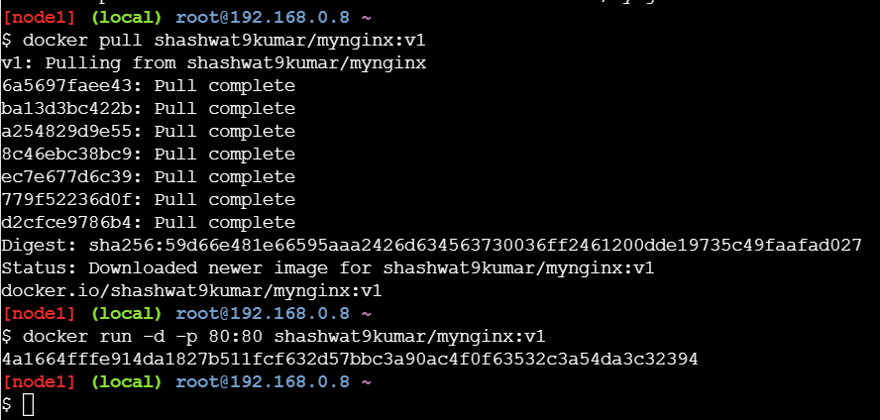

* Visit the running container on port 80:

